Data Sheet
Product Information
Product Name | : | Recombinant Mouse Interleukin 2 (rmIL-2)
Synonyms | : | IL2, TCGF, lymphokine, interleukin 2
Description | : | Interleukin-2 (IL-2) is an interleukin, a type of cytokine signaling molecule in the immune system. It is a protein that regulates the activities of white blood cells that are responsible for immunity. In the thymus, where T cells mature, it prevents autoimmune diseases by promoting the differentiation of certain immature T cells into regulatory T cells, which suppress other T cells that are otherwise primed to attack normal healthy cells in the body. IL-2 also promotes the differentiation of T cells into effector T cells and into memory T cells when the initial T cell is also stimulated by an antigen, thus helping the body fight off infections. (Ref. From Wikipedia)
NCBI Accession No. | : | NM_008366.3
Amino acid sequence | : | MAPTSSSTSSSTAEAQQQQQQQQQQQQHLEQLLMDLQELLSRMENYRNLKLPRMLTFKFYLPKQATELKDLQCLEDELGPLRHVLDLTQSKSFQLEDAENFISNIRVTVVKLKGSDNTFECQFDDESATVVDFLRRWIAFCQSIISTSPQ
Molecular Mass | : | 17.3 kDa (150 a.a)
Protein Tags | : | No tagging
Source | : | E. coli.
Cat. No. | : | JW-M009-0010, JW- M009-0025, JW-M009-0100, JW-M009-0250, JW-M009-0500, JW-M009-1000
Storage | : | Should be at ≤ -70 ℃ as undiluted aliquots of handy size. Avoid repeated freezing and thawing.
Cross Reactivity | : | Human

Quality Control
Test items |  |  |  | Specifications
Appearance |  |  | : |  | Clear, colorless liquid
Purity |  |  | : |  | Greater than 98 % by RP-HPLC and SDS-PAGE
Specificity |  |  | : |  | Using Western blot, detection | 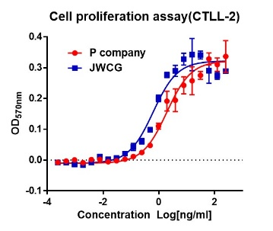
Concentration |  |  | : |  | 0.1 mg/㎖, Bradford method
Biological Activity |  |  | : |  | Determined by proliferation of CTLL-2 indicator cells.  The ED50 is ≤ 0.2 ng/ml, corresponding to a specific activity of ≥ 5 x 10⁶ EU/mg
Endotoxin |  |  | : |  | Less than 0.1 EU/㎍ as determined by the LAL method
Formulation |  |  | : |  | PBS, 5% Glycerol (pH 7.4) without preservative or carrier proteins.
Stability |  |  | : |  | Stable for up to 12 months at -70 ℃. Stable for a month at 4 ℃.
Sterility |  |  | : |  | Sterilized through a 0.2 ㎛ membrane filter and packaged aseptically. Culture for 2 weeks, no growth

